Random Test Data Generation

Iteration Report



Course: Bachelor of Science (Honours) in Software Development

Name: Kyle Kinsella

Date when document was started: 13/02/2024

Supervisor: Chris Meudec

**How to make a eclipse plugin: An Overview**

In order to make an eclipse plugin I did some research and I found this website [1], this website was a good starting point for me to get started to making my first plugin. After I completed reading the documentation on what to do, I visited [2], to try and find a video to try and put what I had read into practise.

I followed the steps within the video [2] and when I was done, I had made my first eclipse plugin. Then I had did some research on how to put my plugin onto the eclipse marketplace so other people can use my plugin worldwide [3] when I visited this website I had to make an eclipse account in order for me to be able to upload my plugin to the eclipse marketplace. Then I clicked on “Add Content” then “Add a new Solutions Listing”, then you fill out a form then it is sent for moderation, you have to have your project stored in a GitHub repository of some kind so they can see you code behind your plugin [4].

Below I have my Java code that runs my eclipse plugin:

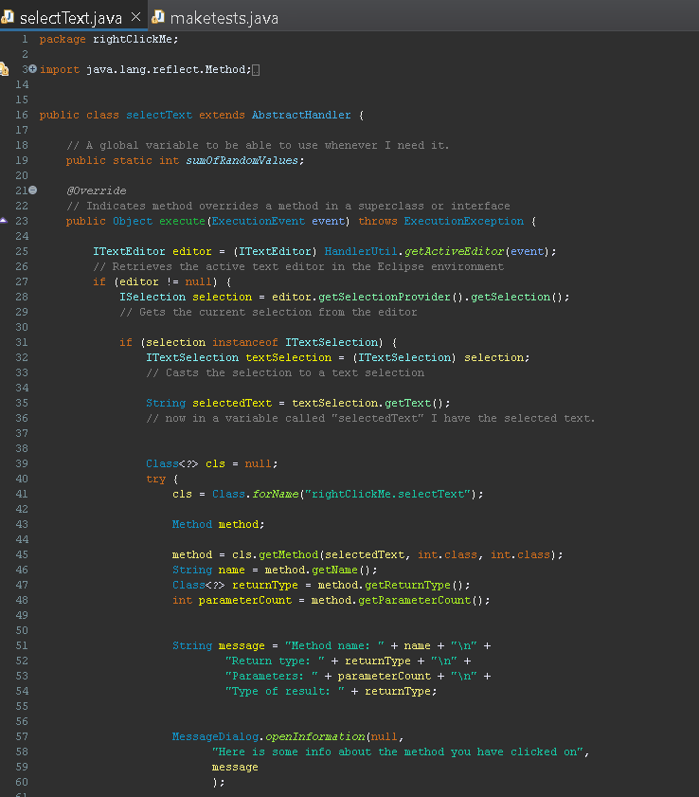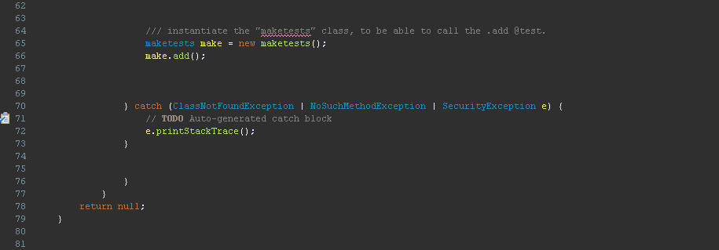

Here is my Java test code that runs my eclipse plugin:

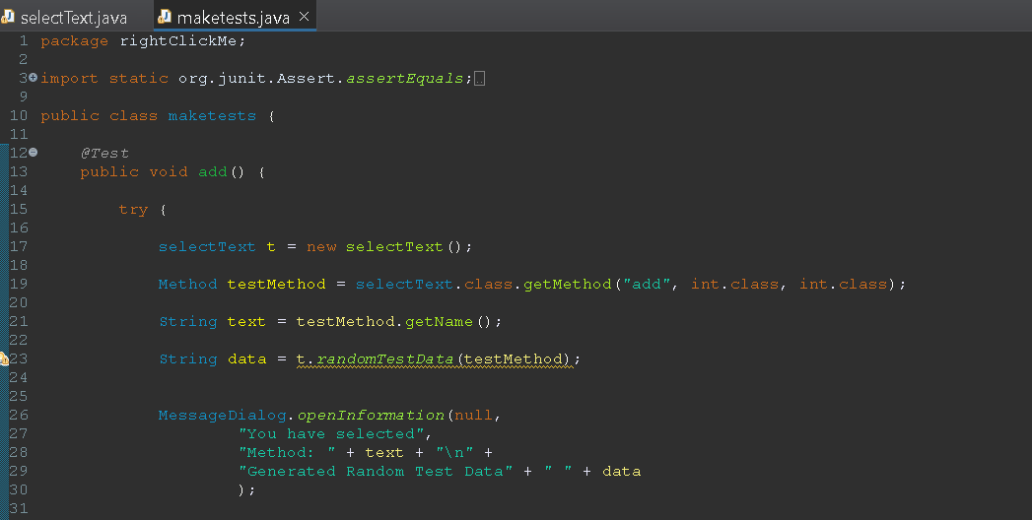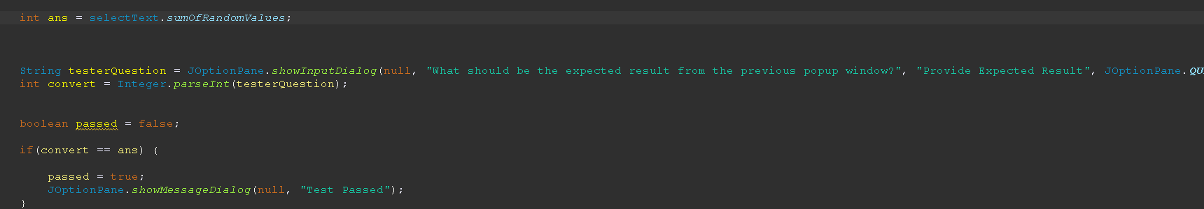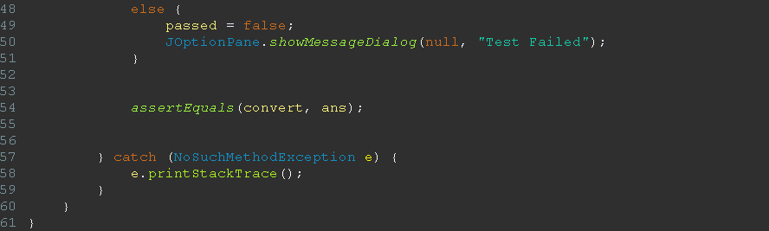

Below is the output of my plugin when I run it: 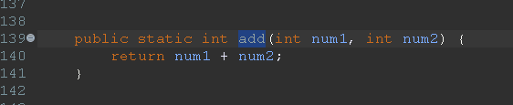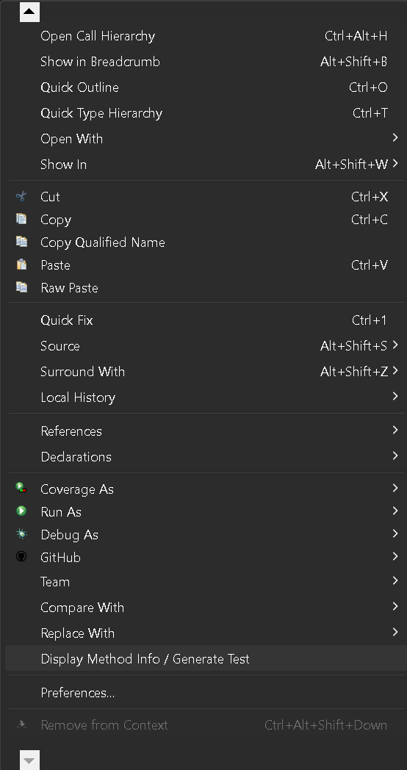

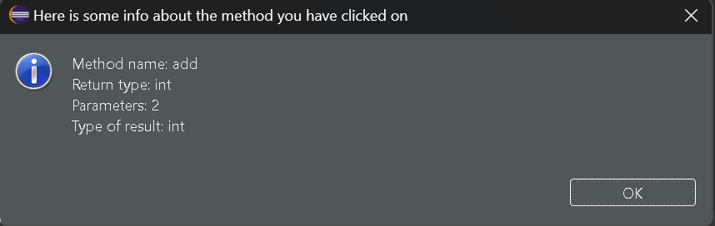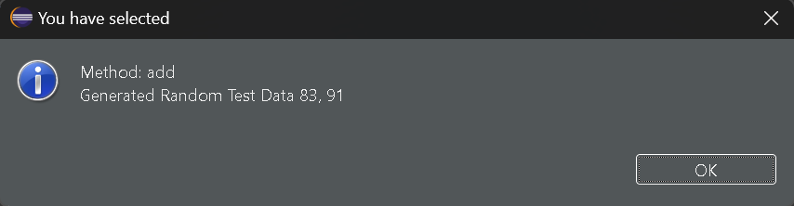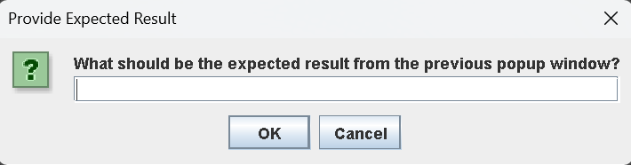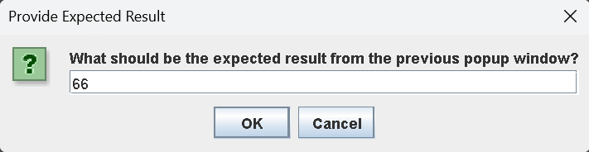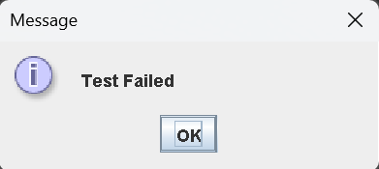

If you input the correct answer it will show what is below:

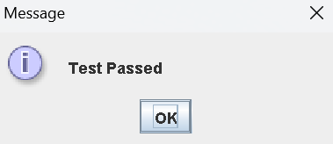

**Constructing the right click: Overcoming Obstacles**

During this iteration one of my biggest problems was trying to get the right click functionality to work. Before I even started to code the right click I did some research on how to make a right click plugin in Eclipse, when I was browsing Google I couldn't get a whole lot of help but I did find the Oracle Java Api [5]. This was very helpful for me because it shows Method Summaries and lots more. After hours of research I couldnt find anything other than [5] to help me, so I asked ChatGPT for some help, I asked him a few simple questions such as “How do I show a message when you right click ?” and a few more. After using this tool I did some coding and didnt get any functionality for about 3 - 4 days.

**Different Java Code**

I will say making this project in the Java programming language is perfectly fair, but when you go to make a plugin within Eclipse the programming language is still in Java but the code is extremely different and very hard to understand. Because I didn't understand the code it made it even harder to make and understand how to make a Eclipse Java Plugin. When I did a Youtube search [7], for anything to do with making a plugin, I would get nothing informative back in order to help me code out the right click functionality.

Now I am going to show you the difference between the different types of Java code that I have used for my project.

1. Normal Java code
2. Plugin Java Code

Writing normal Java code is somewhat easy because if you don’t know what to do you can just do a Google or a Youtube search. Here is a commit of my code from the start of my project, this code is relatively very simple to understand [8].

Now I comparison to the somewhat simple Java code above, here is what the right click Java code looks like [9], this code will just show a message once you right click on a button called “Generate Test”. But the code looks very different, and when you want to make a right click checker the code looks even harder and it is very hard to understand when you have not see that kind of code before and there is no help online.

Below is an image of the code for the normal Java code:

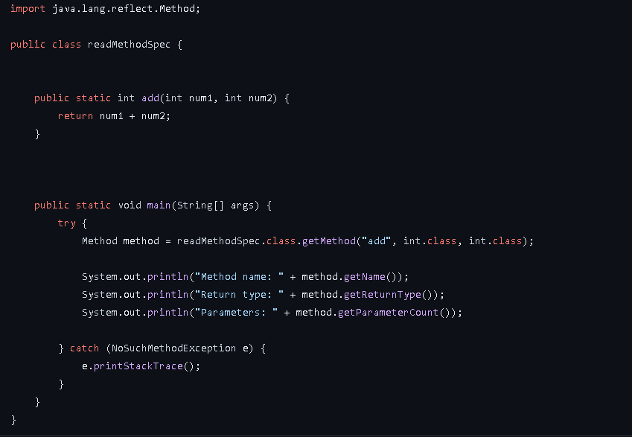

Below is an image of the code for the plugin Java code: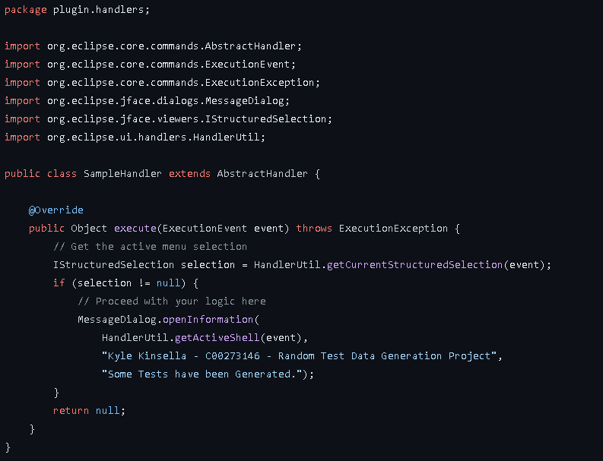

Below is an image of the XML code for the plugin:

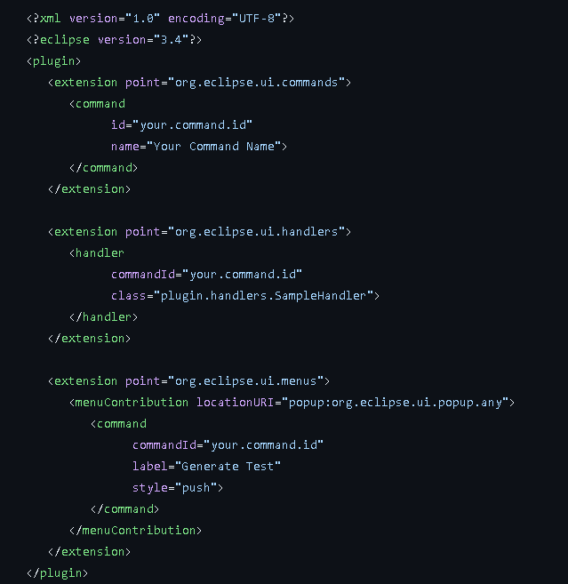

**Finally a Solution**

After days and hours of coding and trying to figure out why the code wasnt working, I finally got the right click to work. How I got it to work was I was asking ChatGPT [6] some questions and after each response I got back I was starting to understand what the code does. So I just looked back at each conversation I had with ChatGPT and I just combined the code from previous conversations and put all of my code together and eventually I got the right click to work. So now when you right click on a method name or any piece of text my software is able to detect what you have clicked on.

**Making the test’s**

In order for me to be able to make my JUnit tests for my project, I had to install JUnit into my working directory for my project. I watched this YouTube video to help me install JUnit into my project [10].

**References**

1. IBM. (2024). Creating eclipse plugin. Retrieved from: <https://www.ibm.com/docs/en/rtw/9.2.0?topic=eclipse-creating-plug-in-project>
2. YouTube. (2024). Publish custom eclipse plugin. Retrieved from: <https://www.youtube.com/watch?v=BhZSe6Tkipk>
3. Eclipse Marketplace. (2024). Upload my plugin. Retrieved from: <https://marketplace.eclipse.org/>
4. GitHub. (2024). My first plugin code. Retrieved from: <https://github.com/KyleKinsella/Random-Test-Data-Generation/blob/main/My%20first%20plugin/SampleHandler.java>
5. Eclipse Platform. (2024). Java Api. Retrieved from: <https://rtist.hcldoc.com/help/index.jsp?topic=%2Forg.eclipse.platform.doc.isv%2Freference%2Fapi%2Forg%2Feclipse%2Fui%2Fhandlers%2FHandlerUtil.html>
6. ChatGPT. (2024). Used for help. Retrieved from: <https://chat.openai.com/?model=text-davinci-002-render-sha>
7. Youtube. (2024). Tried to find some information for help. Retrieved from: <https://www.youtube.com/results?search_query=ITextEditor+java+help>
8. GitHub. (2024). Read Method Spec Code. Retrieved from: <https://github.com/KyleKinsella/Random-Test-Data-Generation/blob/main/Read%20Method%20Spec%20Code/readMethodSpec.java>
9. GitHub. (2024). I made a right click. Retrieved from: <https://github.com/KyleKinsella/Random-Test-Data-Generation/tree/main/I%20made%20a%20right%20click>
10. YouTube. (2024). How to install JUnit in Eclipse. Retrieved from: <https://www.youtube.com/watch?v=BOHs67tC-QE&t=751s>